# Problem 1 – Tic-Tac-Toe Power

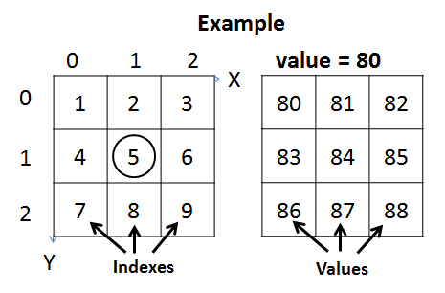You are given tic-tac-toe board (**3 columns and 3 rows**) like the one the right. As inputs you will be given the **X** and **Y** **coordinates** of one of the cells. Each of the **cells** in the field has an **index** and a **value** (look at the examples on the right). You will be given the value of the **first** **cell V** (**index1**). Each of the next cells will have value **greater by 1** than the **previous**. **Example**: if value=80, then index1=80, index2=81, index3=82, ..., index9=89. Your task is to print on the console the **value** of the cell **C** raised to the **power** of its **index**: **C index**. Look at comments in the examples below to understand your task better.

### Input

The input data should be read from the console.

* At the **first line** you will be given the **X** coordinate.
* At the **second line** you will be given the **Y** coordinate.
* At the **third line** an integer number **V** will be given,specifying the value of the first cell.

The input data will always be valid and in the format described. There is no need to check it explicitly.

### Output

The output should be printed on the console. It should consist of **1** **line**:

* Print the **value** **C** of the cell at position {X, Y} raised to the power of its **index**.

### Constraints

* The **X** and **Y** inputs will be integers in the range [0…2].
* The **V** input will be an integer in the range [0…100].
* Allowed working time: 0.2 seconds. Allowed memory: 16 MB.

### Examples

|  |  |  |  |
| --- | --- | --- | --- |
| **Input** | **Output** | **Board** | **Comments** |
| 1  1  10 | 537824 | 0 1 2  0 |10 | 11 | 12  1 |13 | **14** | 15  2 |16 | 17 | 18 | The cell with coordinates {x=1, y=1} has an index 5. Cell at index 5 has value = 14.  145 =537824 |

|  |  |  |  |  |  |  |  |
| --- | --- | --- | --- | --- | --- | --- | --- |
| **Input** | **Output** |  | **Input** | **Output** |  | **Input** | **Output** |
| 2  1  5 | 1000000 | 0  0  1 | 1 |  | 2  0  88 | 729000 |